Phylogenetic Analysis of 16S rRNA Gene Sequences of Bacteria
(Rohit Bhavsar, 5th March 2026)

- Objective:- To construct and interpret a phylogenetic tree using 16S rRNA sequences of selected organisms and understand their evolutionary relationships.

- 16S rRNA is widely used in phylogenetic analysis because it is universally present in bacteria, contains both conserved and variable regions, evolves slowly, and serves as a reliable molecular marker for determining evolutionary relationships and identifying bacterial species.

- Organism used for 16S rRNA sequences:-
- Escherichia coli NR_024570
- Bacillus subtilis NR_112116
- Staphylococcus aureus NR_074995
- Pseudomonas aeruginosa NR_074828
- Rhizobium leguminosarum NR_026078
- Anabaena variabilis NR_074316
- Methanococcus jannaschii (Archaea) NR_074393

- Materials & Methods:-
- NCBI database
- FASTA format
- Alignment tool (MUSCLE)
- Phylogenetic tool (MEGA)

- Step 1: Download file

- Go to NCBI Nucleotide database:- The sequence were retrieved form the NCBI database which provides a comprehensive and reliable source of nucleotide and protein data. It was used due to it accessibility , accuracy, and availability of sequence in FASTA format.

- Enter accession number Open sequence page:- An accession number is a unique identifier assigned to a biological sequence in a database (If there is no accession number, use the name of the organism)
- Download FASTA format:- standard format for storing nucleotide and protein sequences.

- Combine all sequences into one FASTA file:- multiple sequence alignment and phylogenetic analysis efficiently.

- Step 2: sequence alignment

Purpose:- The phylogenetic tree construction to align homologous sequence positions so that accurate evolutionary relationships can be determined.

- Perform multiple sequence
alignment using MEGA:- It provides reliable methods for evolutionary analysis.

- Align → Edit/Build Alignment
- new alignment (DNA)
- Import FASTA file
- Alignment → MUSCLE:- MUSCLE (Multiple Sequence Comparison by Log Expectation) is a modern alignment Algorithm.
- high accuracy.
- faster processing.
- iterative refinement.
    - Note:- Set a parameter as default.

- Run alignment
- Save aligned file in the .mas format:- A .mas file stores aligned sequences and is used for phylogenetic tree construction in MEGA.

- Step 3: Phylogenetic tree construction
(Construct phylogenetic tree using Neighbor-Joining method)

- Go to Phylogeny → Construct Neighbor Joining Tree:- The Neighbor-Joining method was used to construct the phylogenetic tree based on genetic distance among sequences. This method efficiently grouped related organisms and helped in understanding their evolutionary relationships.
- Select aligned file (.mas file)

- Set parameters:-
- Substitution model : Kimura 2 parameter (K2P):- The Kimura 2-Parameter model was used to calculate evolutionary distances, as it distinguishes between transition and transversion mutations, providing more accurate phylogenetic analysis.
Transitions:
A ↔ G
C ↔ T

Transversions:
A ↔ C
A ↔ T
G ↔ C
G ↔ T

- Gaps: Partial deletion (95%):- Site coverage cutoff 95% removes positions with gaps and keeps only reliable alignment regions for tree construction.

- Bootstrap: 1000 replicates:- Bootstrap analysis measures statistical confidence in tree branches. The dataset is resampled multiple times and trees are reconstructed. Shows confidence in each branch
Higher value = more reliable.

Bootstrap value Confidence
90–100 very strong support
70–89 strong support
50–69 moderate support
<50 weak support

- Compute the data

- Step 4: Phylogenetic tree Analysis:-

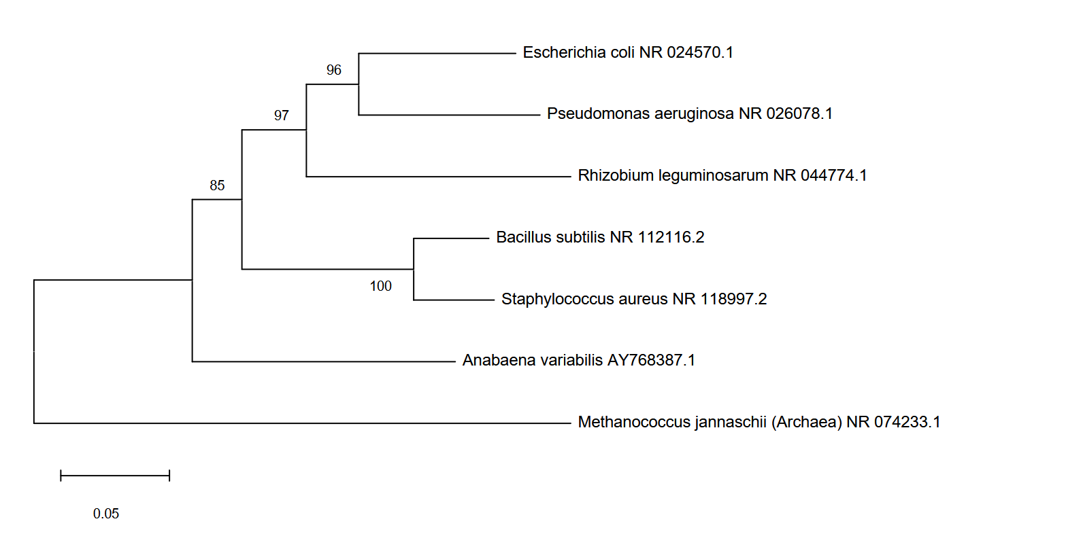

- Nodes:-
- Points where branches split.
- Each node represents a common ancestor.

- Branches:-
- Lines connecting nodes.
- Represent evolutionary pathways.
- Longer branches indicate more genetic changes.

- Branch length scale:-
- Example:
0.02
Unit:
0.02 substitutions per nucleotide site
- Meaning approximately 2% sequence divergence.

- Clades:-
- Groups of organisms sharing a common ancestor.

- Closest relationships :-
- Esherichia coli and Pseudomonas aeruginosa form the most closely related pair (boostrap value 96)
- This indicates a high level of sequence similarity between these two species.

- Next closest :-
- Rhizobium leguminosarum branches next to the E. coli – P. aeruginosa clade with strong support (boostrap value 97) showing that it more closely related to this pair than to the Gram - positive bacteria

- Bacillus subtilis and Staphylococcus aureus cluster together with very high support (boostrap value 100), indicating they are very closely related to each other.

- Outgroup:-
- Methanococcus jannaschii (Archaea) is placed at the base of the tree as an outgroup, confirming that it is evolutionarily the most distant from all the other taxa.

